Instructions to get USB uP operational:

Plug in the USB device,
When windows finds new hardware select the driver manually:
J:\TDAS\demonstrators\Embed\Cypress_uP\Driver_CyUsb

You can see the device in the device manager:
It might be neccessary to disconnect en reconnect the board.
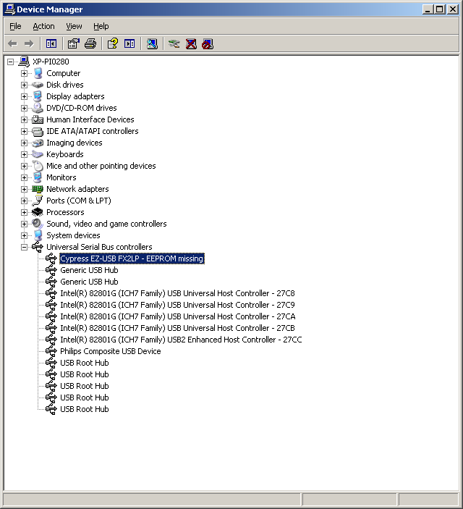

Start: J:\TDAS\demonstrators\Embed\Cypress_uP\CyConsole EZ-USB.lnk
You see 2 screens popping up:
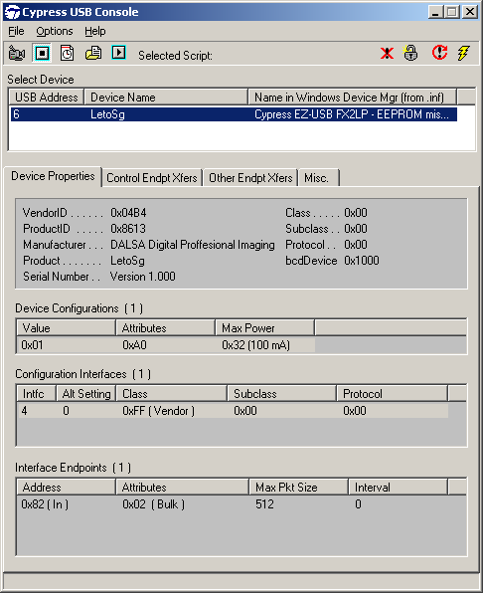
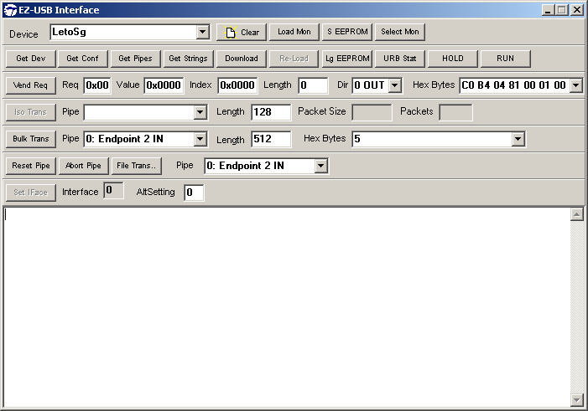

You can choose download to download the required iic-file.

